SQL QUERIES
EMPLOYEE ATTRITION ANALYTICS
BUSINESS QUESTIONS SOLVED
1. The HR wants to prioritize which employees needs the most attention in each department.
Use row number in ranking the employees within the department.
WITH rankedemployee AS(
SELECT
employee_id,
department,
job_satisfaction,
ROW_NUMBER() OVER (PARTITION BY department ORDER BY job_satisfaction ASC) AS satisfaction_rank
FROM employee_attrition
)
SELECT employee_id,department,job_satisfaction
FROM rankedemployee
WHERE satisfaction_rank = 1;
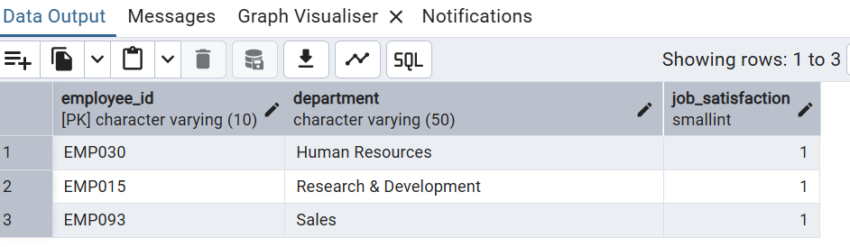
2. Which department has the least job satisfaction value?
SELECT department,AVG(job_satisfaction)AS avg_satisfaction
FROM employee_attrition
GROUP BY department
ORDER BY avg_satisfaction ASC
LIMIT 1;
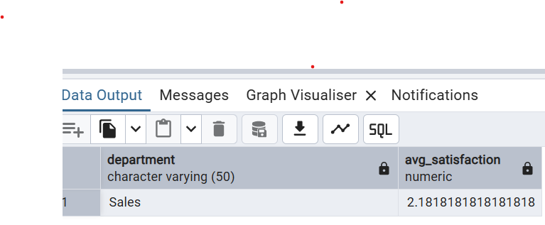
3. Who are the top 3 performers in each department?
WITH rankedemployees AS (
SELECT
employee_id,
department,
performance_rating,
ROW_NUMBER() OVER (PARTITION BY department ORDER BY performance_rating DESC) AS perf_rank
FROM employee_attrition
)
SELECT employee_id, department, performance_rating
FROM rankedemployees
WHERE perf_rank <= 3;
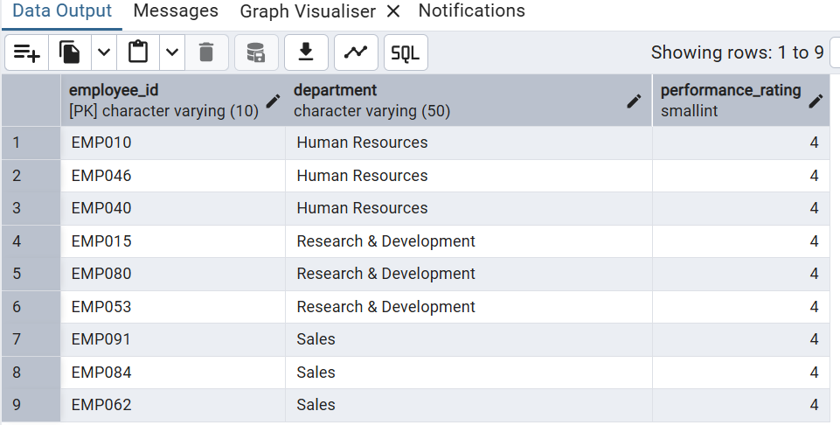
4. Identify employees who are likely to leave comparing their individual performance to the department average.

SELECT employee_id, department, job_satisfaction,
AVG(job_satisfaction) OVER (PARTITION BY department) AS dept_avg_satisfaction,
job_satisfaction - AVG(job_satisfaction) OVER (PARTITION BY department) AS diff_from_avg
FROM employee_attrition;
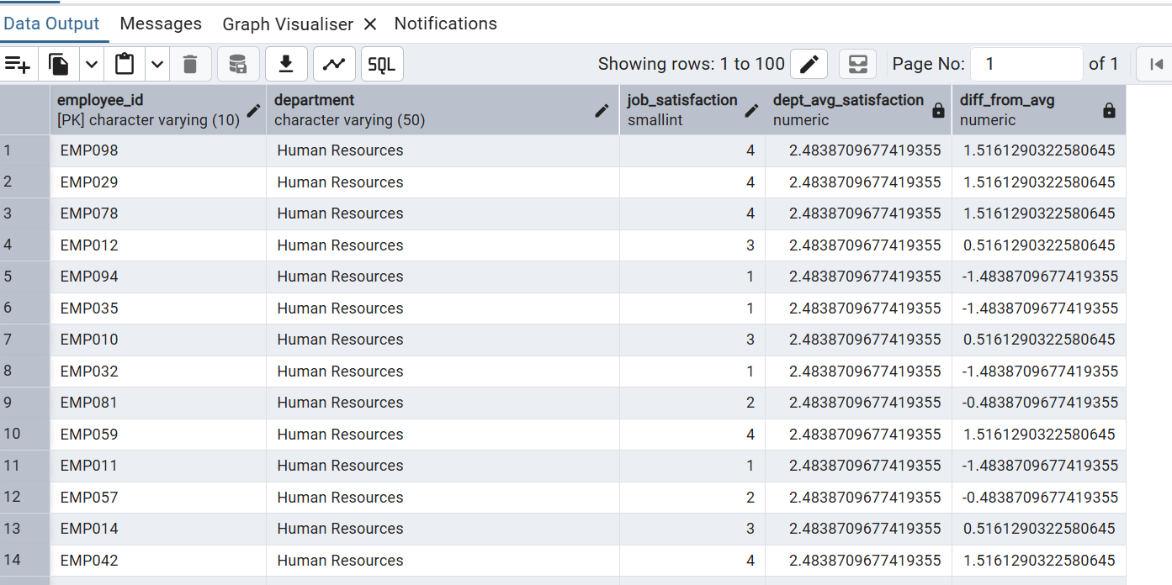
5.Identify number of employees per department
SELECT department, COUNT(*) AS total_in_department
FROM employee_attrition
GROUP BY department;
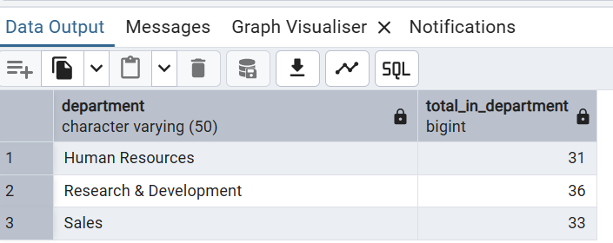
6. Compare employees job satisfaction based on years of stay
SELECT employee_id, age, years_at_company, job_satisfaction,
LAG(job_satisfaction) OVER (PARTITION BY department ORDER BY years_at_company) AS prev_emp_satisfaction,
LEAD(job_satisfaction) OVER (PARTITION BY department ORDER BY years_at_company) AS next_emp_satisfaction
FROM employee_attrition;
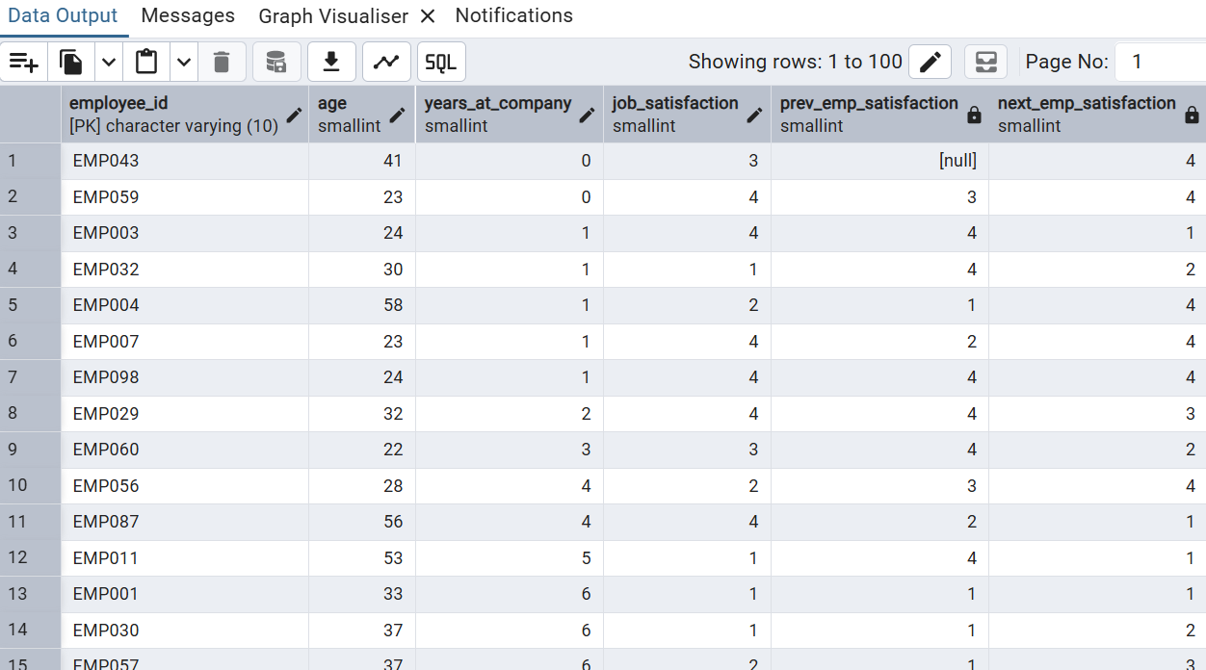
7. Segment the workforce into veteran,senior,mid role and junior role based on total working years.
SELECT employee_id, total_working_years,
NTILE(4) OVER (ORDER BY total_working_years) AS experience_quartile
FROM employee_attrition;
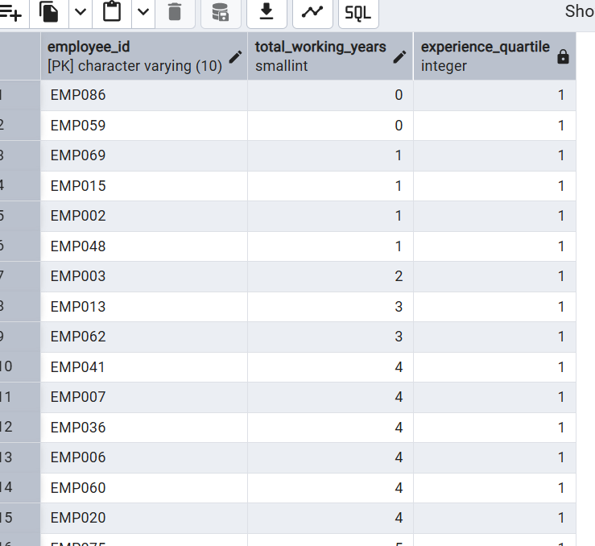
8. Identify employees who have gone the longest without a promotion.A key frustration that can lead to resignation.

SELECT employee_id, department, years_since_last_promotion,
MAX(years_since_last_promotion) OVER (PARTITION BY department) AS max_no_promotion,
MIN(years_since_last_promotion) OVER (PARTITION BY department) AS min_no_promotion
FROM employee_attrition;
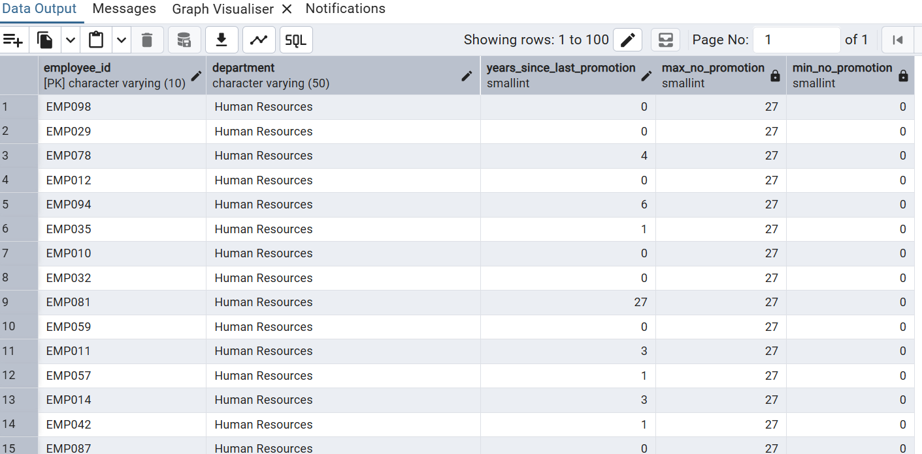
9. Evaluate attrition rate for employees with job satisfaction value at 1.
SELECT
COUNT(CASE WHEN attrition = 'Yes' THEN 1 END) AS left_count,
COUNT(*) AS total_score1_employees,
ROUND(
COUNT(CASE WHEN attrition = 'Yes' THEN 1 END) * 100.0
/ COUNT(*), 1
) AS attrition_pct
FROM employee_attrition
WHERE job_satisfaction = 1;
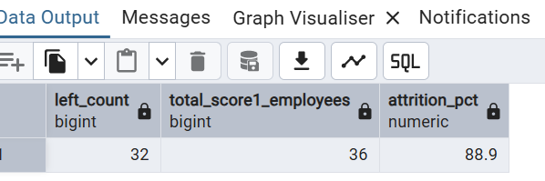
10. Evaluate the attrition rate for employees with poor work life balance rated 1
SELECT
COUNT(CASE WHEN attrition = 'Yes' THEN 1 END) AS left_count,
COUNT(*) AS total_wlb1_employees,
ROUND(
COUNT(CASE WHEN attrition = 'Yes' THEN 1 END) * 100.0
/ COUNT(*), 1
) AS attrition_pct
FROM employee_attrition
WHERE work_life_balance = 1
